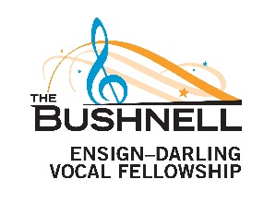

APPLICATION: SIGNATURE PAGE

Certification

I certify that all the information in this application is true. I acknowledge that supplying false information on this application disqualifies me from consideration for this scholarship.

Signature of Applicant Date

Parent/Guardian Consent

I certify that I am the parent/guardian of the applicant, and that I give my permission for the applicant to participate in this audition process and the Vocal Fellowship program. I certify that all the information in this application is true. I acknowledge that supplying false information on this application disqualifies the applicant from consideration for this scholarship.

Signature of Parent/Guardian Date

Primary Reference

I certify that I recommend the applicant for participation in this audition process and the Vocal Fellowship program. I certify that all information in this application is, to my knowledge, true. I acknowledge that supplying false information on this application disqualifies the applicant from consideration for this scholarship.

Signature Date

Application Check List
Please make sure you have included the following:

- A complete resume and/or full completion of the application form __
- All required signatures __
- A photocopy of your birth certificate or passport __
- 3 photographs of applicant that are similar in nature __
- Letter(s) of recommendation
(individually sealed and signed across the flap or emailed under separate cover) __

